

SAVEETHA SCHOOL OF ENGINEERING

SAVEETHA INSTITUTE OF MEDICAL AND
TECHNICAL SCIENCES

DEPARTMENT OF COMPUTER SCIENCE AND ENGINEERING

LIST OF EXPERIMENTS

COURSE CODE : CSA4001
COURSE NAME : MANAGEMENT INFORMATION SYSTEM

7 Draw a UML diagram for online purchasing system. Provide top level use cases for a web customer making purchases online. Web customer actor uses some web site to make purchases online. Top level use cases are View Items, Make Purchase and Client Register.

AIM:
To design a Use Case Diagram for an Online Purchasing System, illustrating the interactions between Web Customers and the System in viewing items, making purchases, and registering.

PROCEDURE:
• View Items
- Web customers browse available products on the website.
• Make Purchase
- Customers select items, add them to the cart, and proceed with checkout and payment.
• Client Register
- New customers register for an account to store personal details, order history, and payment preferences.

OBSERVATION:

USECASE DIAGRAM:
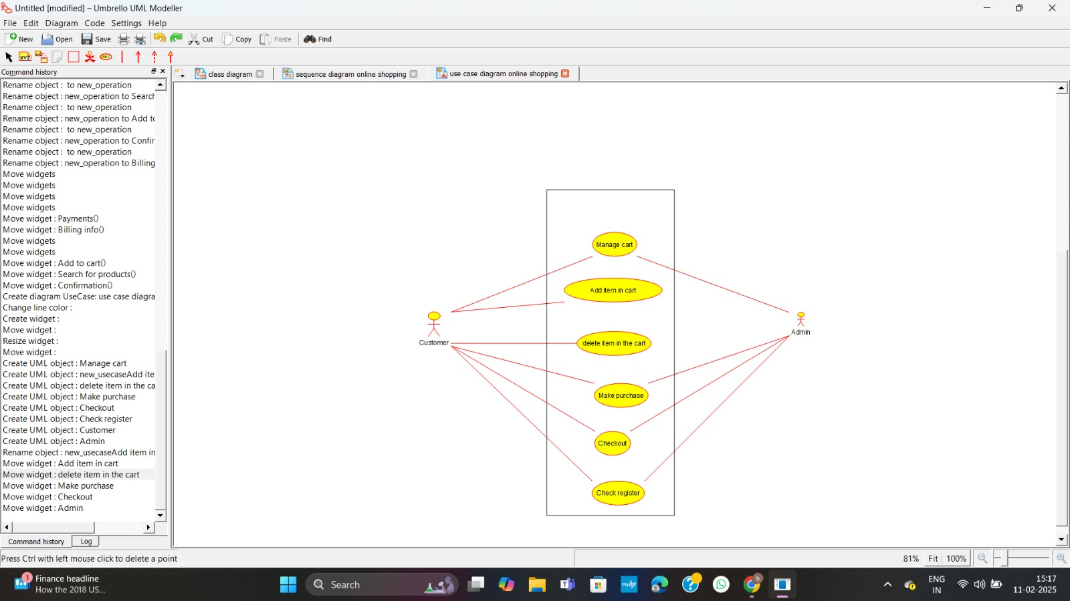

CLASS DIAGRAM:
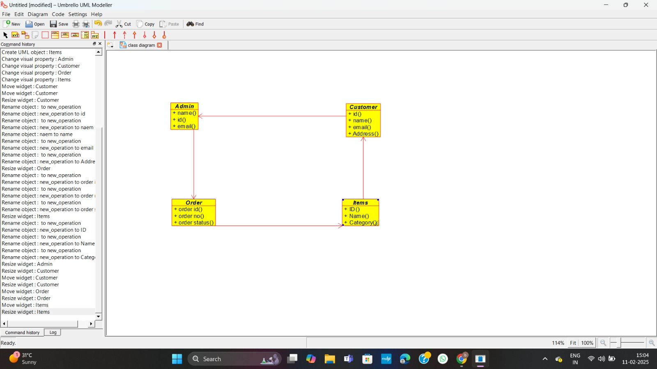
ACTIVITY DIAGRAM:
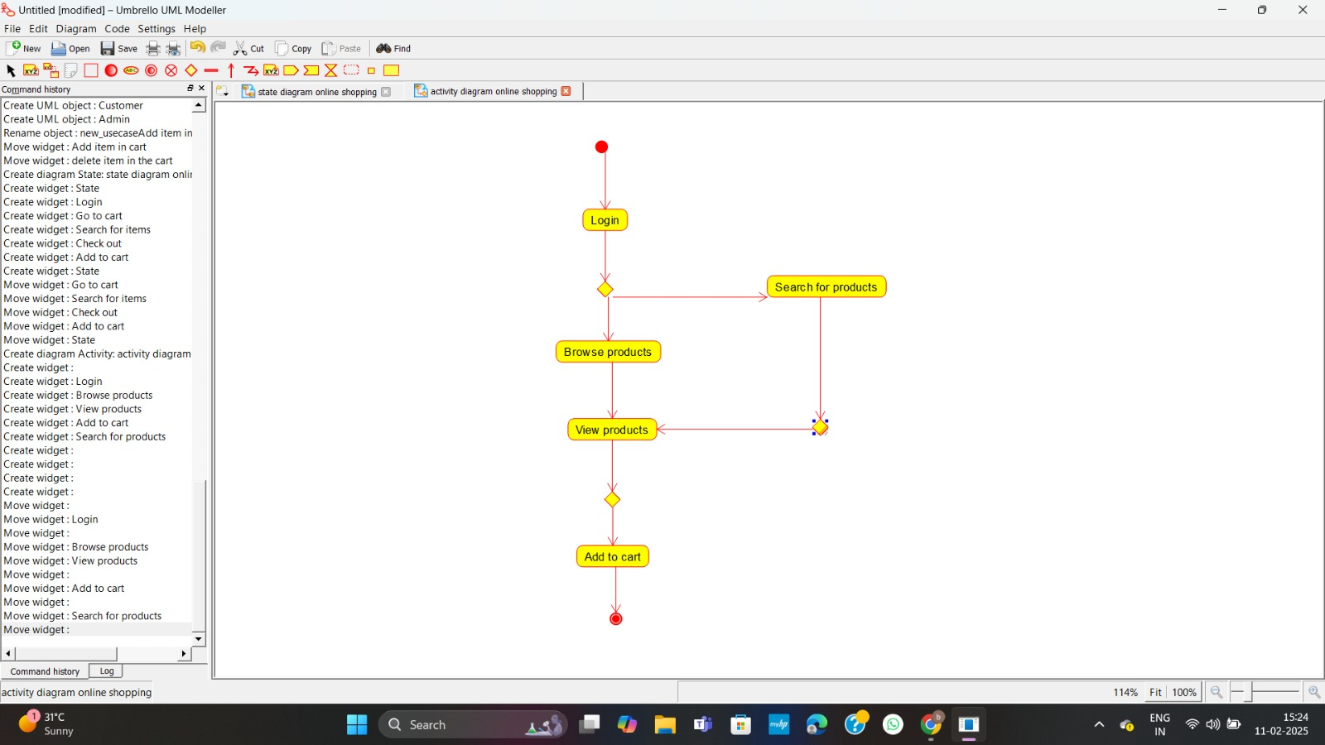

STATE DIAGRAM:
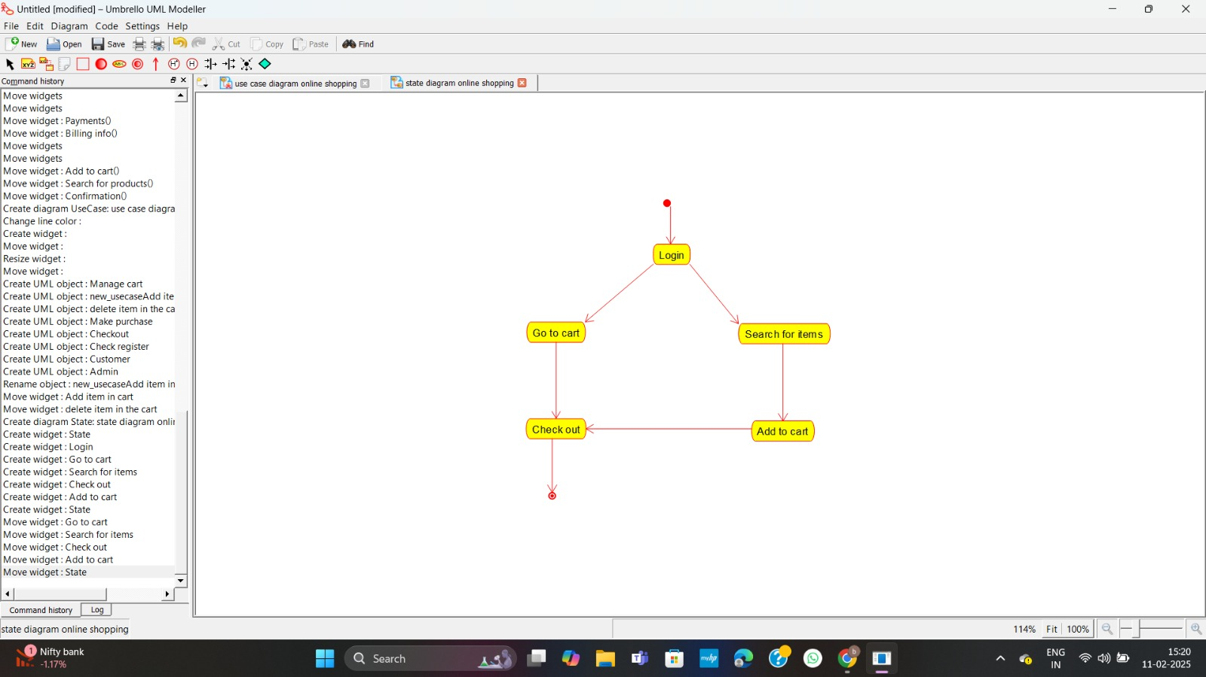

SEQUENCE DIAGRAM:
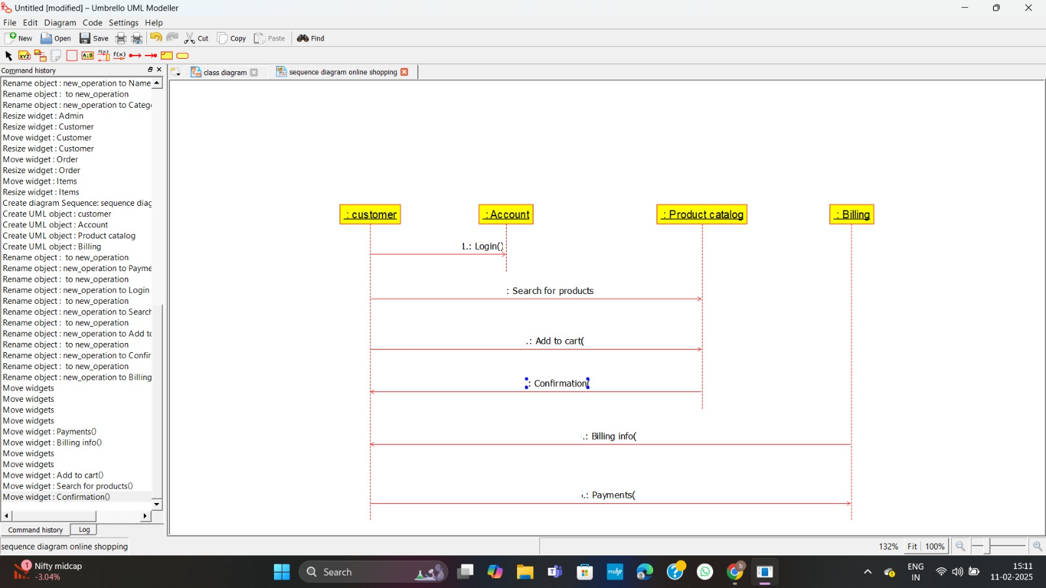

COMPONENT DIAGRAM:
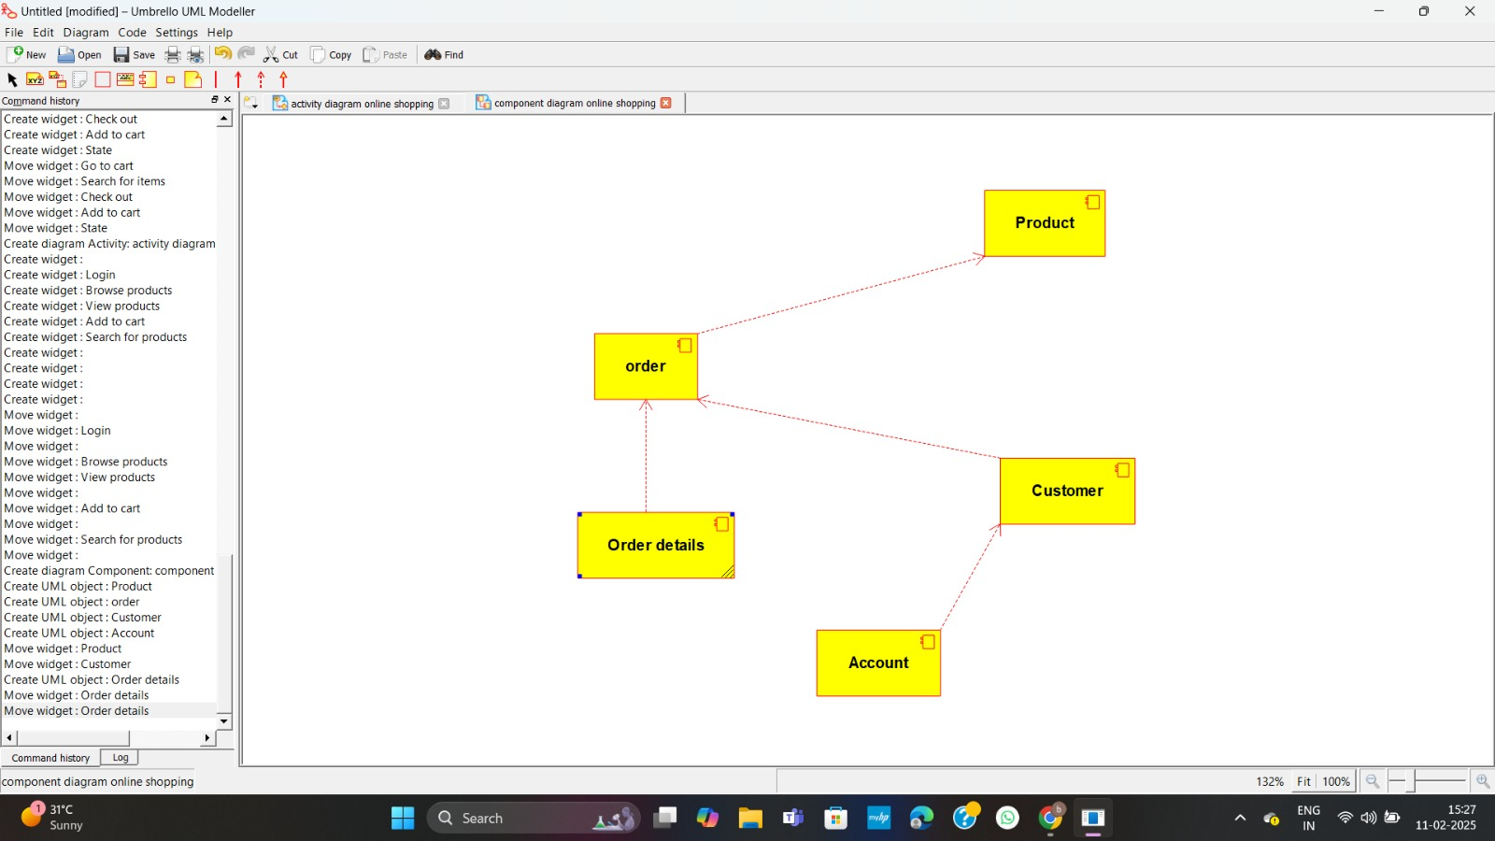

DEPLOYMENT DIAGRAM:
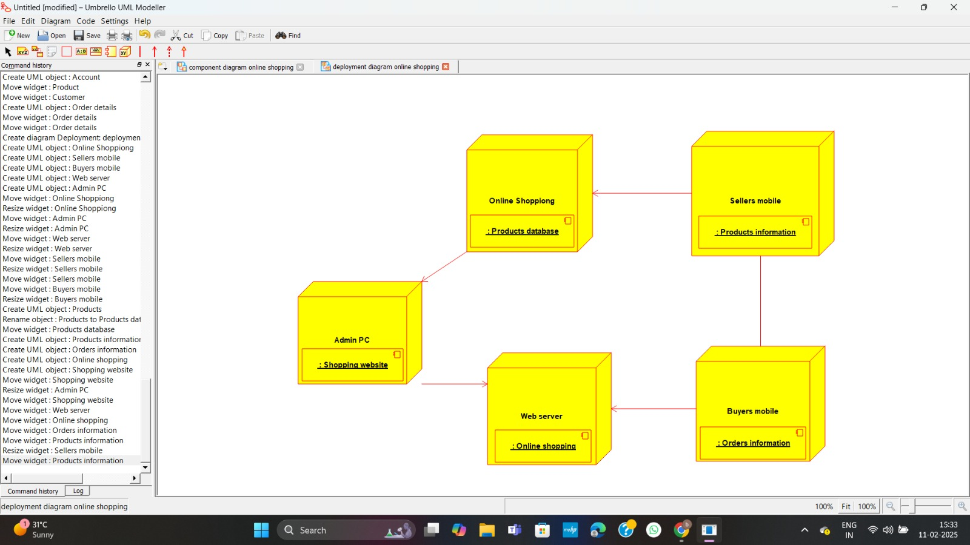

RESULT:

The UML Diagram for the Online Purchasing System has been successfully created, illustrating the interactions between Web Customers and the System in online shopping.

